# Getting started with Python 3

## Installing software: (Already installed on the UiS Computers)

Python: https://www.python.org/downloads/release/python-390/

VSCode: <https://code.visualstudio.com/download>

* Follow the installation instructions according to your platform (Windows/Linux/Mac). This guide is based on using Windows 11, however it should be similar for Linux/Mac.

Recommended VSCode plugins (for ELE610):

* “Python”
* “Qt for Python”
* If you are using GitHub/Git for version control you might consider
  + “Github Copilot”
  + “GitLens”

## Creating / Using a “Virtual environment”

**For VSCode:**

* Create/Open a folder to work in (this could be the folder of scripts supplied with ELE610)
* Create/Open a python script file.
* Click on the bottom right corner to “Select interpreter”. This “field” could also be a version number of the already selected python interpreter.
* Choose “Create Virtual Environment …”

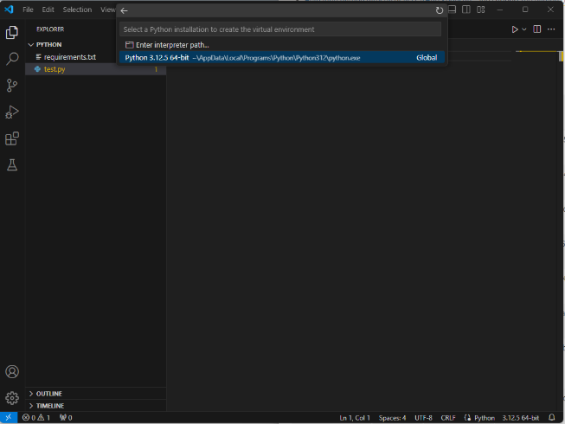

* Create a new virtual environment
* Select the Python interpreter you want to use for the virtual environment. If the version of python you want to use is not in the list, choose path or install it and restart VSCode.

* If you want to automatically install the python packages in the “requirements.txt” file, choose it and select OK. VSCode will then install the required packages (a requirements.txt file is supplied with the course material)

**Command line (Powershell) / VSCode terminal:**

<https://packaging.python.org/en/latest/guides/installing-using-pip-and-virtual-environments/>

Go to the folder containing the python project/files

For Windows:

You can create a virtual environment by running the command:

py -m venv .venv

To activate the virtual environment run the command

“.\.venv\Scripts\Activate.ps1”

To install the required packages run:

pip install -r .\requirements.txt

If you get an error when starting the virtual environment on windows you might have to change the execution policy to allow running the script. You can do this by running the command:

Set-ExecutionPolicy -ExecutionPolicy RemoteSigned -Scope CurrentUse

You can activate the virtual environment as described above, and then manually install additional packages by running:

pip install “packagename”

It can be a good idea to also add the packages you use/install to the requirements file to keep track of packages needed to run the project.